Query the list of *CITY* names starting with vowels (i.e., a, e, i, o, or u) from **STATION**. Your result *cannot* contain duplicates.

**Input Format**

The **STATION** table is described as follows:

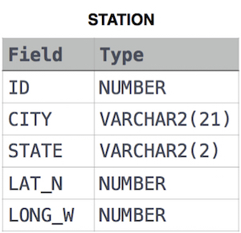

where LAT_N is the northern latitude and LONG_W is the western longitude.